What is NoSQl Database?

What is Cosmos DB? Collections, Documents, Scaling, Throughput, Partition Key,

Demo : Creation of Cosmos DB

What is Collection in Cosmos DB and creation of Collection in Cosmos DB

What is Document in Cosmos DB and creation of Document in Cosmos DB

Can I access Cosmos DB without subscription?

-------------------------------

What is Cosmos DB?

It is schema free

Unlimited scaling (Horizontal as well as Vertical)

Its Document DB (2015) (Its only supported json format)

No Relation (No joins)

Multimodel support (Supports json, tables, graphs)

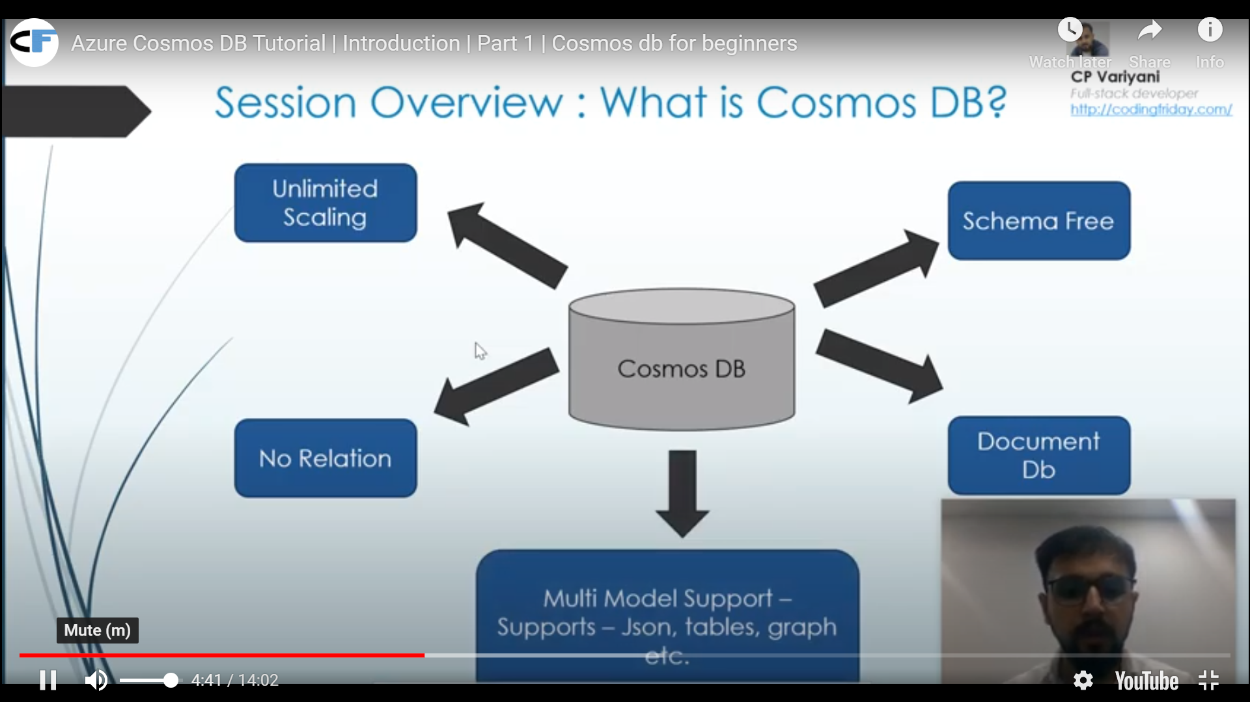

-------------------------------

What is Collection in Cosmos DB

Is it equal to table in SQL?

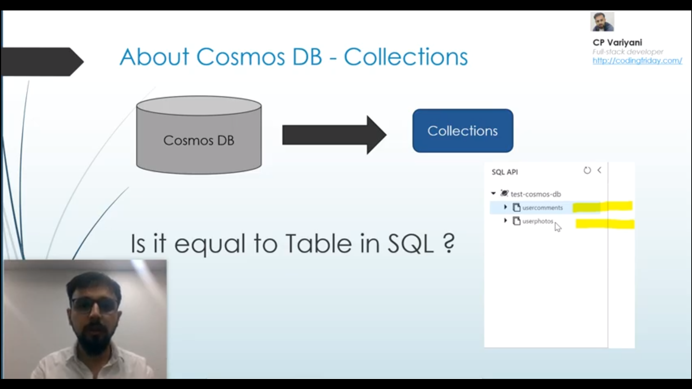

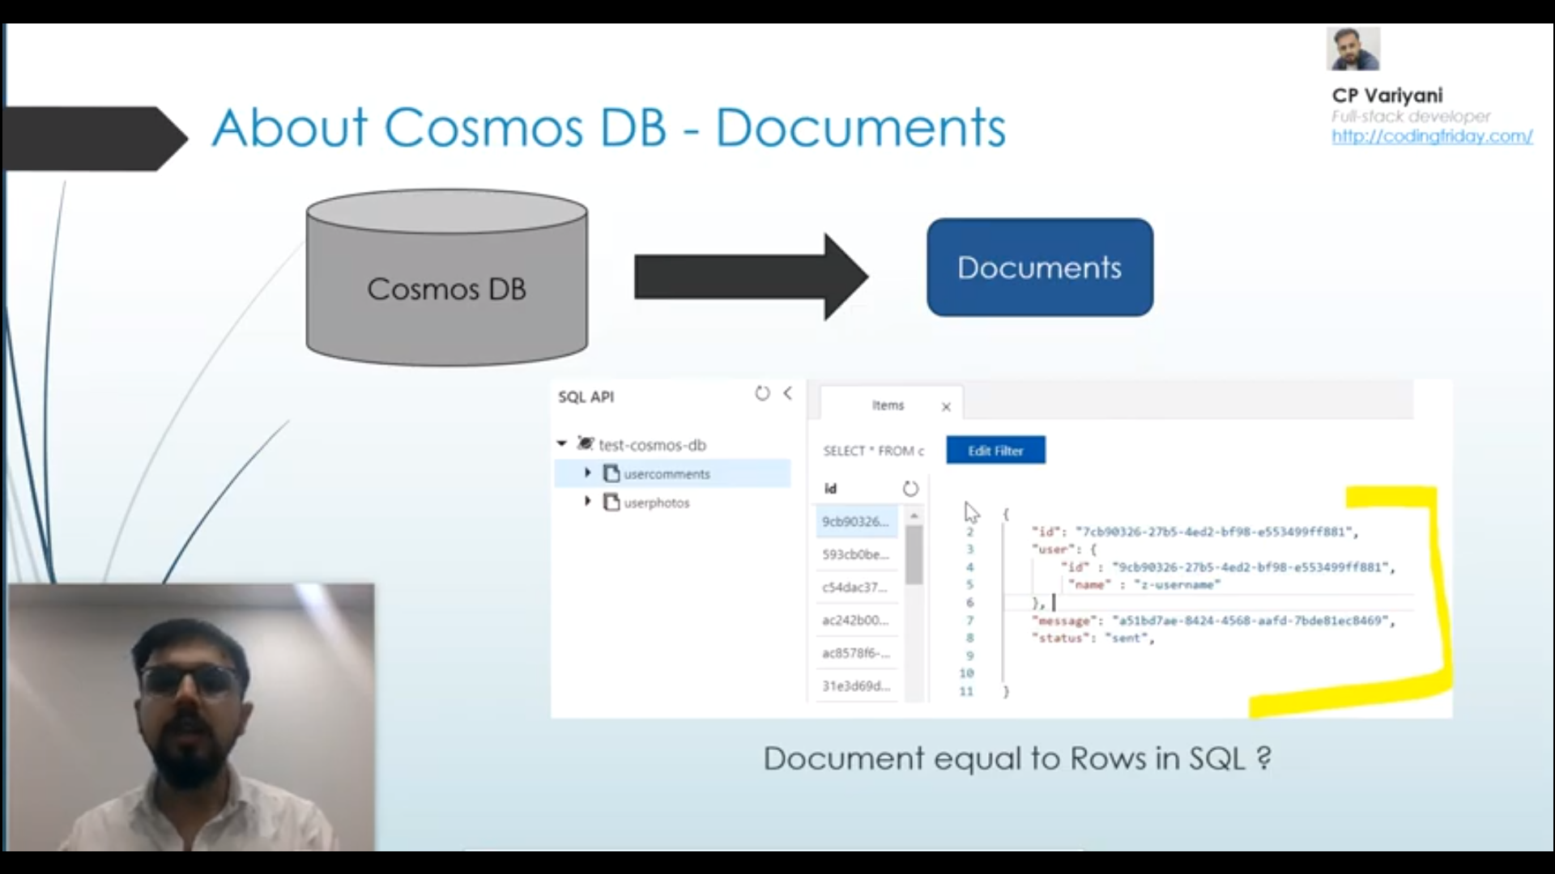

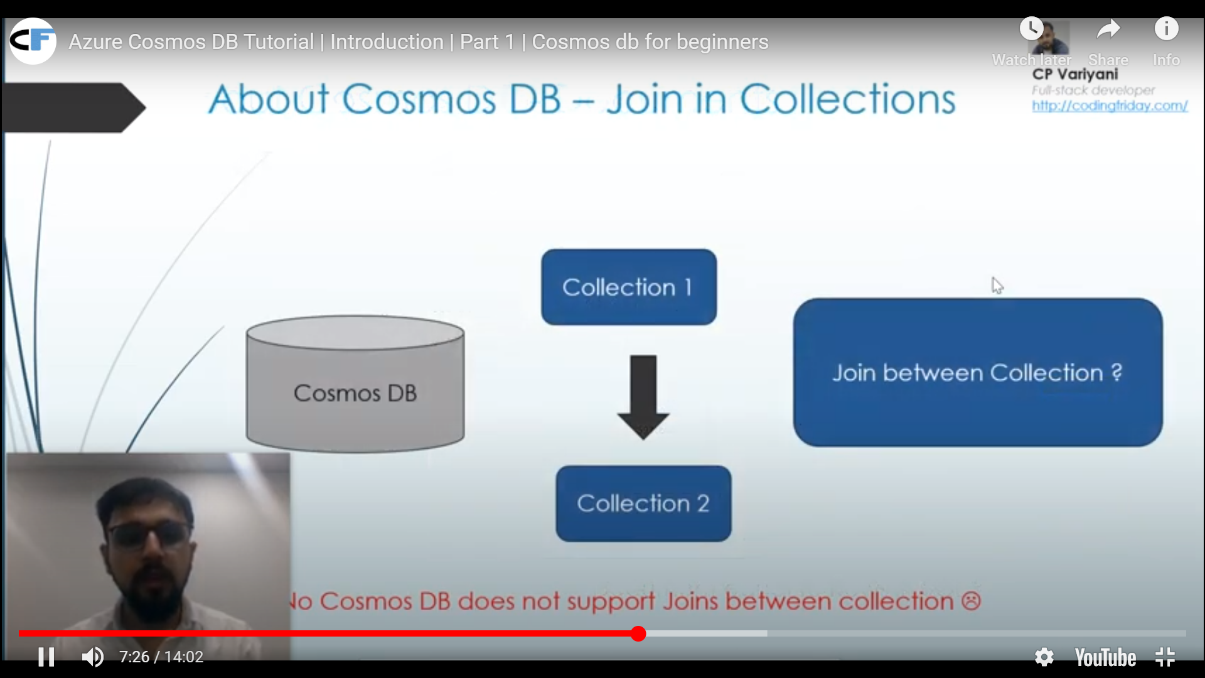

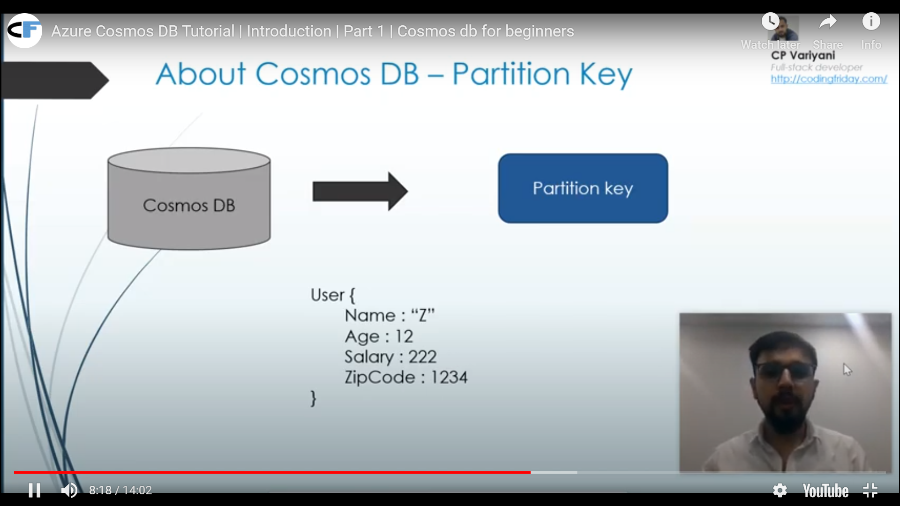

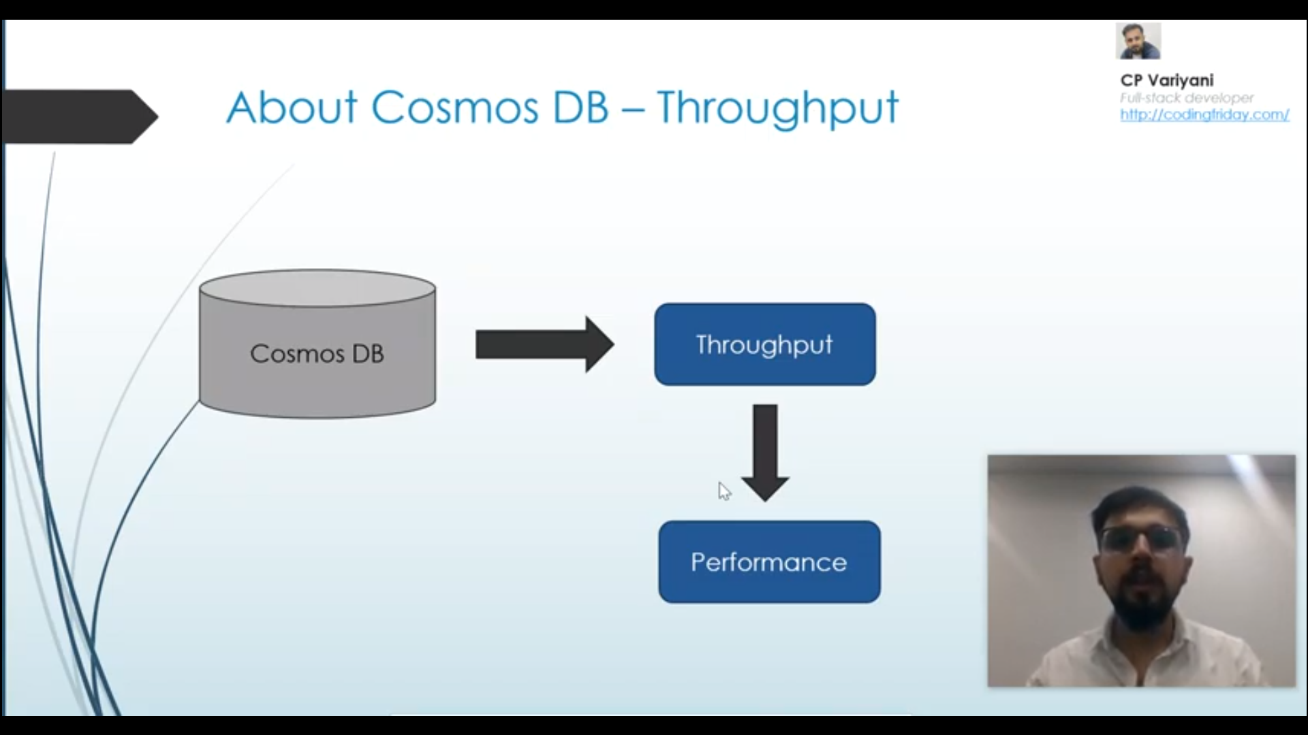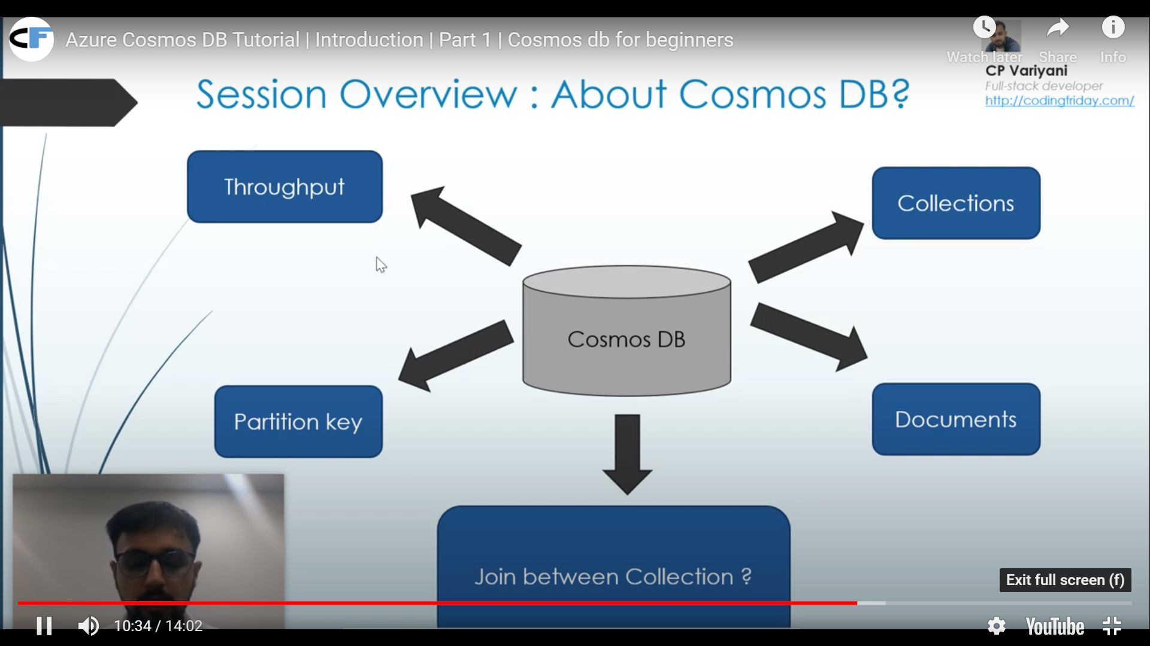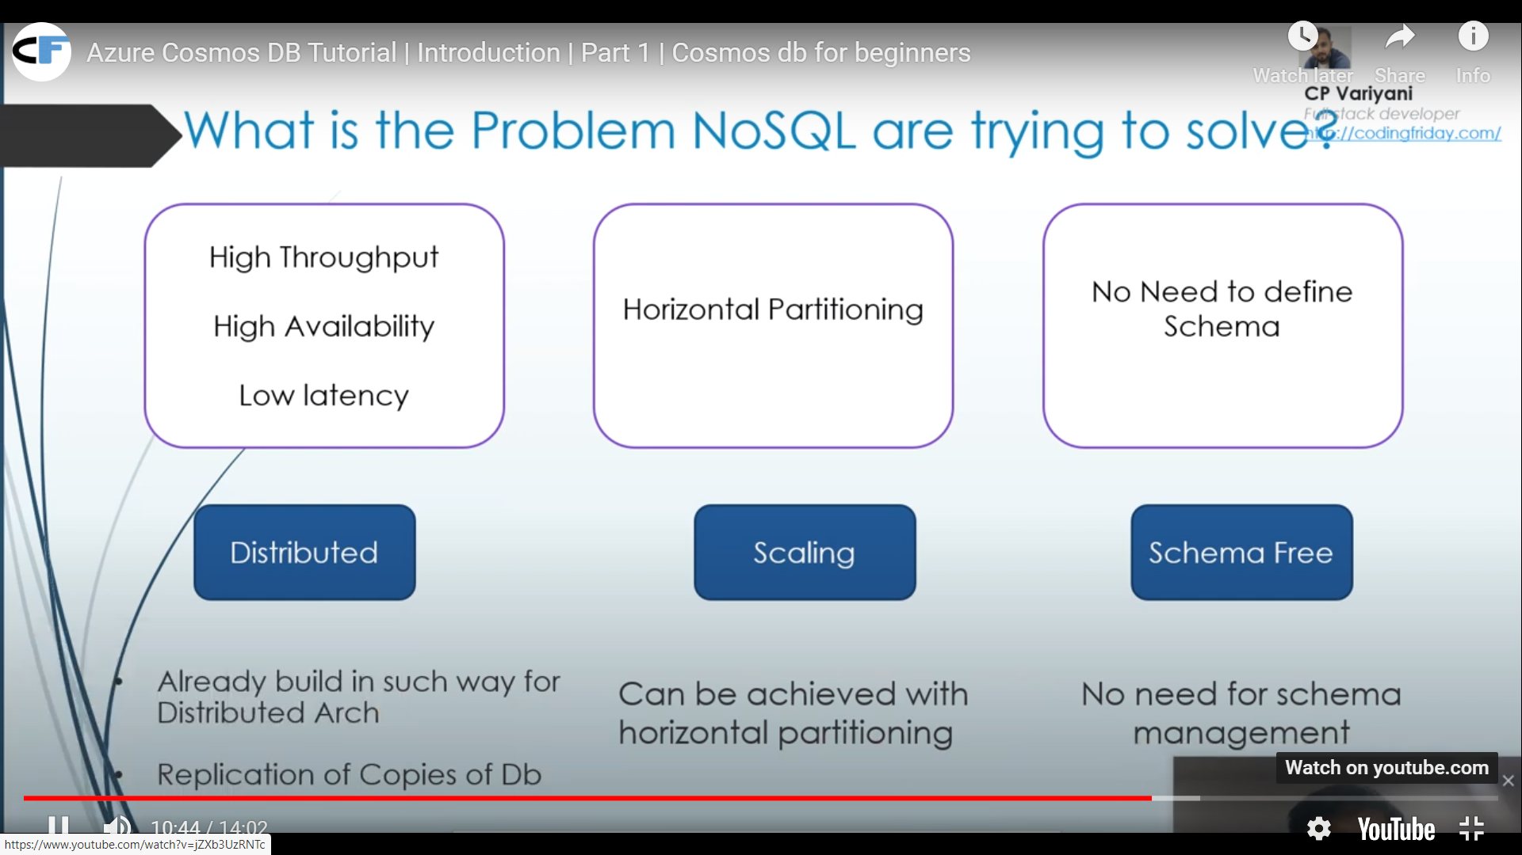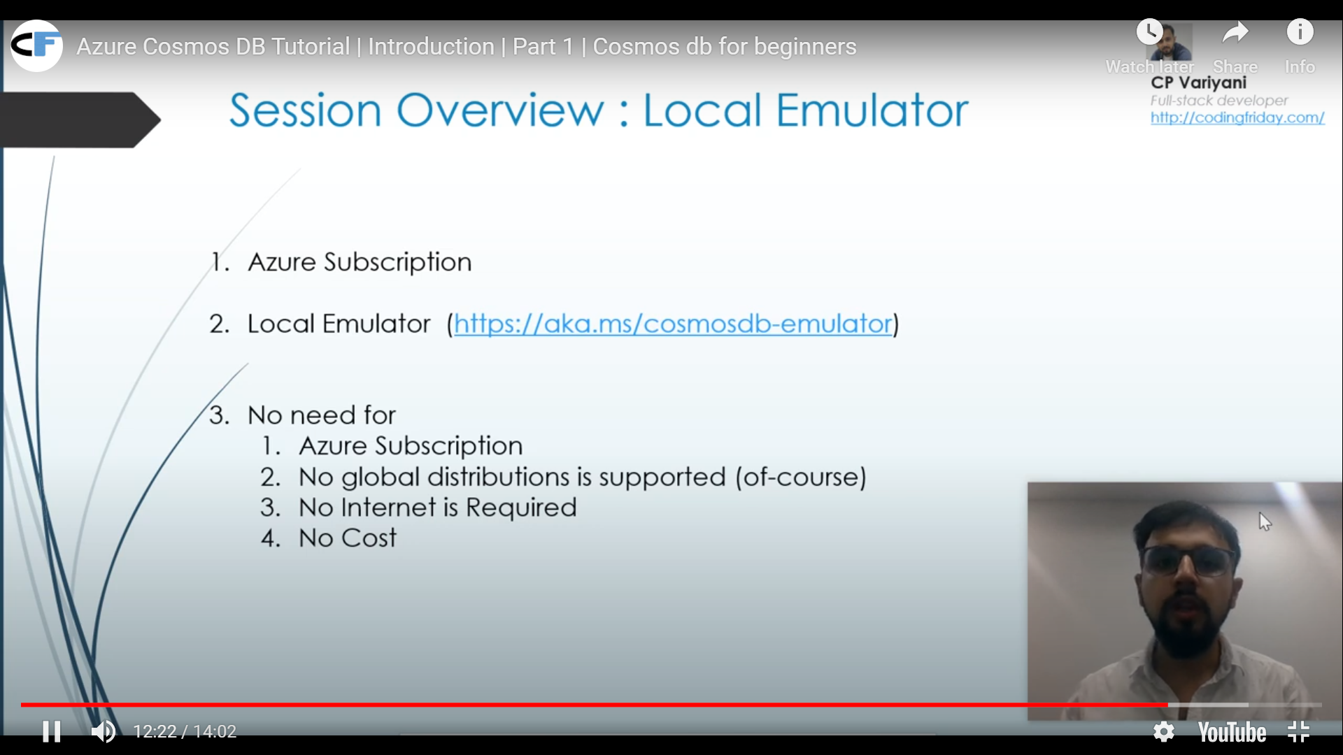

Steps to Create

While using Cosmos DB, we pay for storage consumed by the data and the oprations that we perform on that data.

Any opreartion tat you perfom cusumes some of the database resourcses expressed as Request Unit.

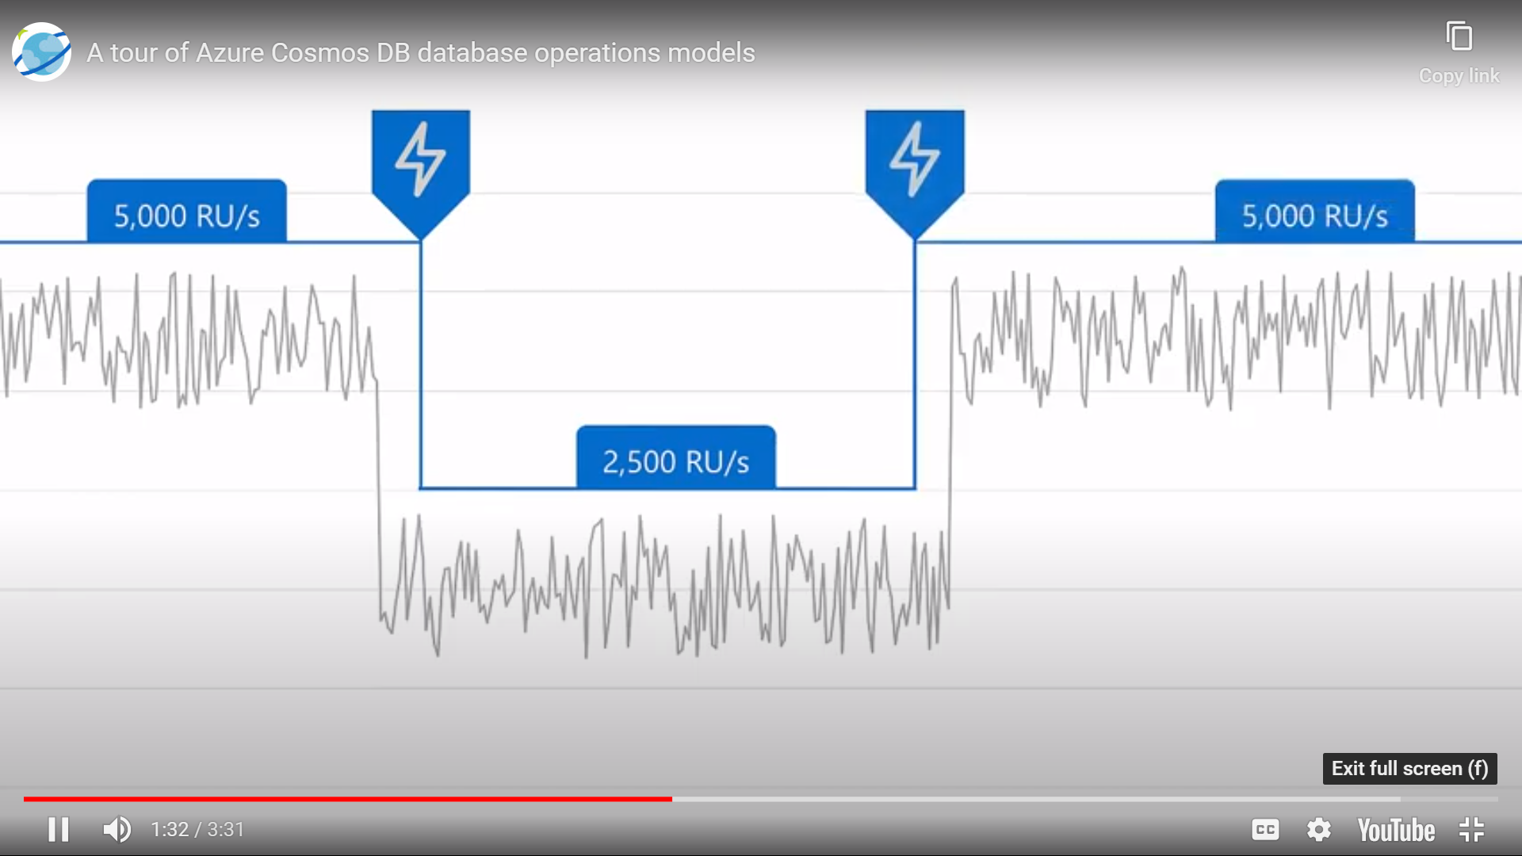 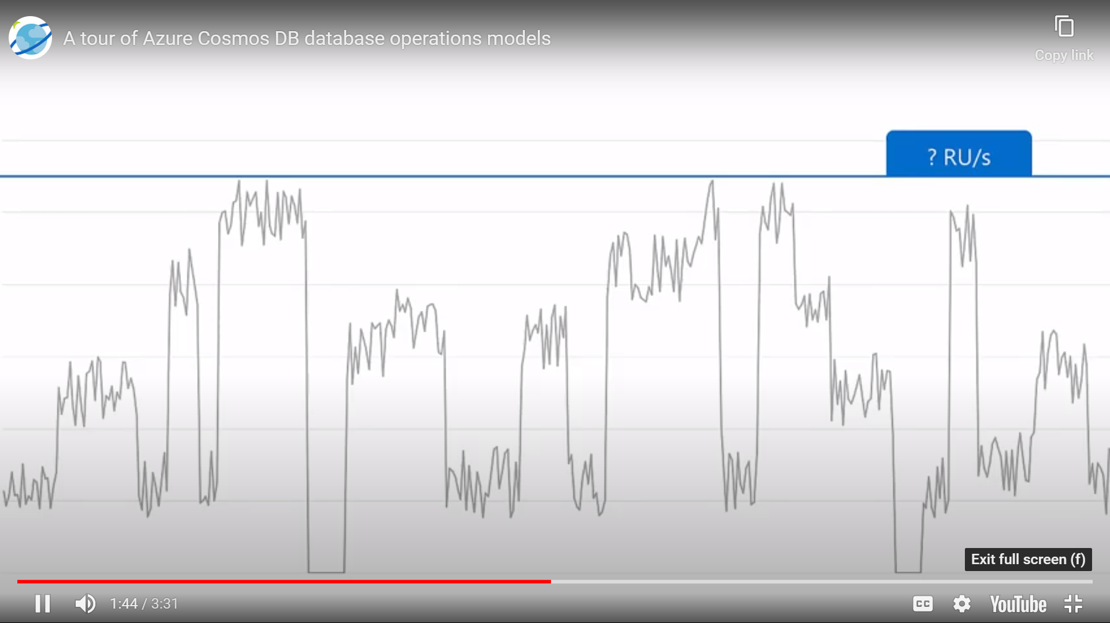

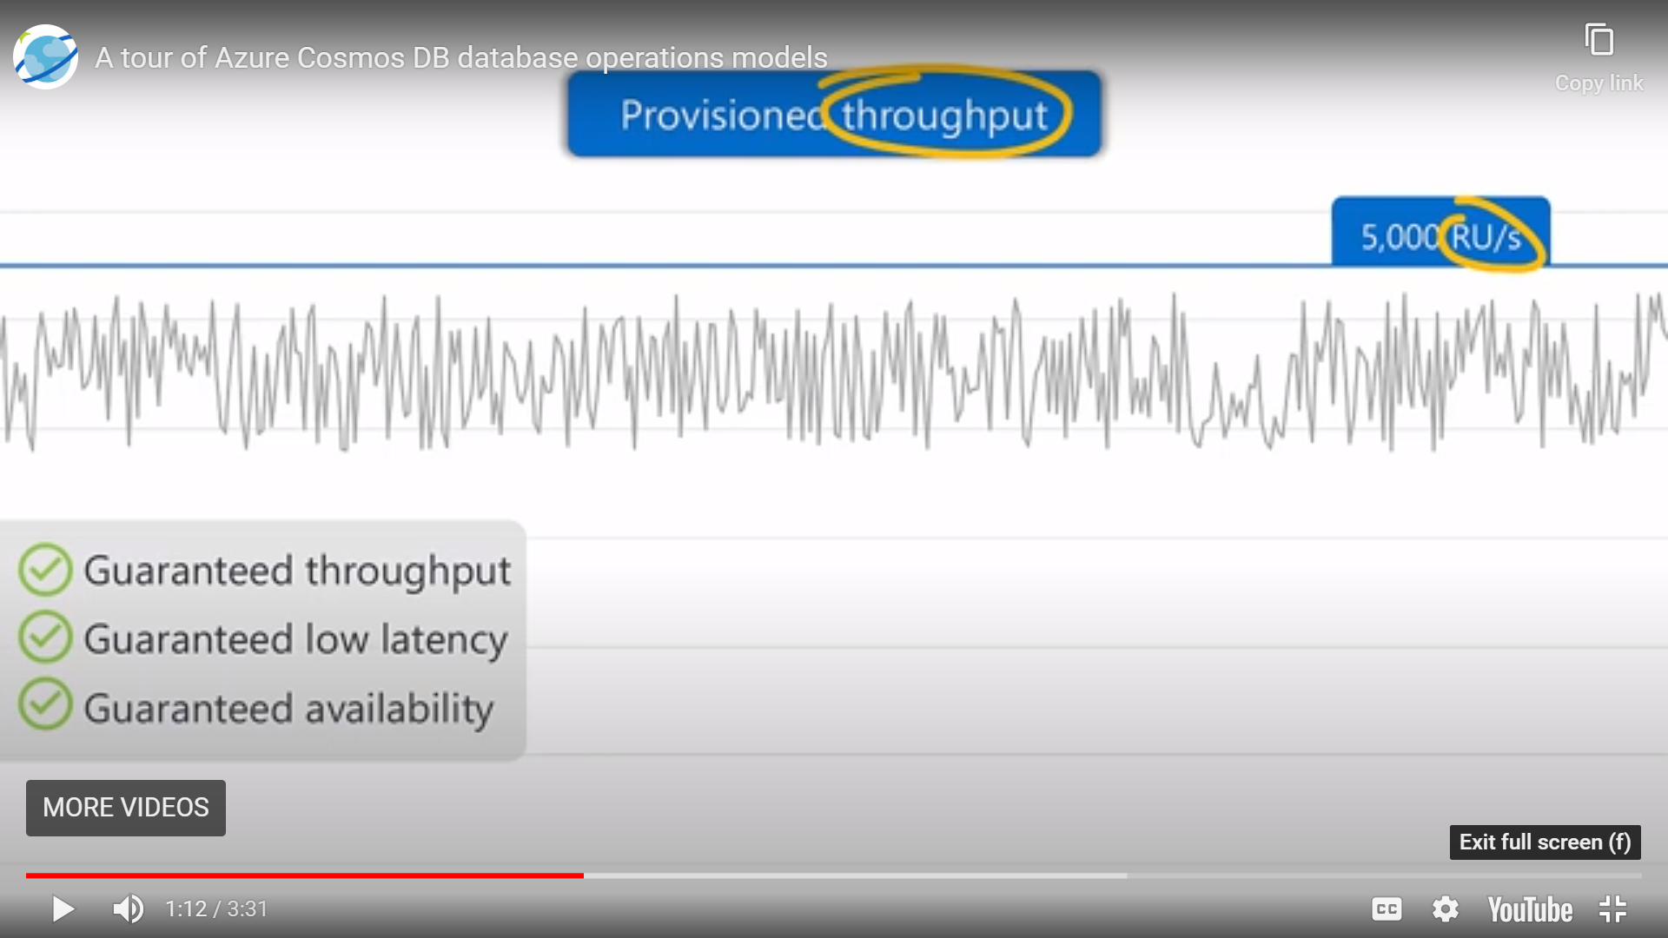 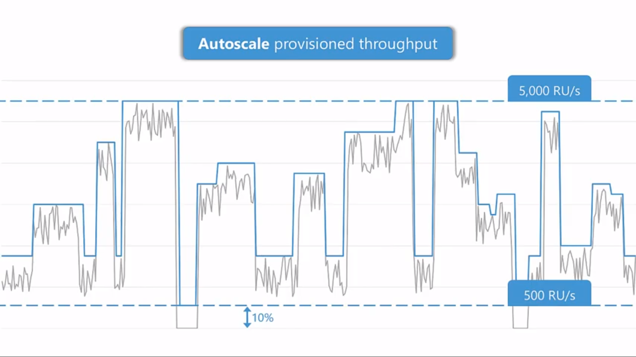

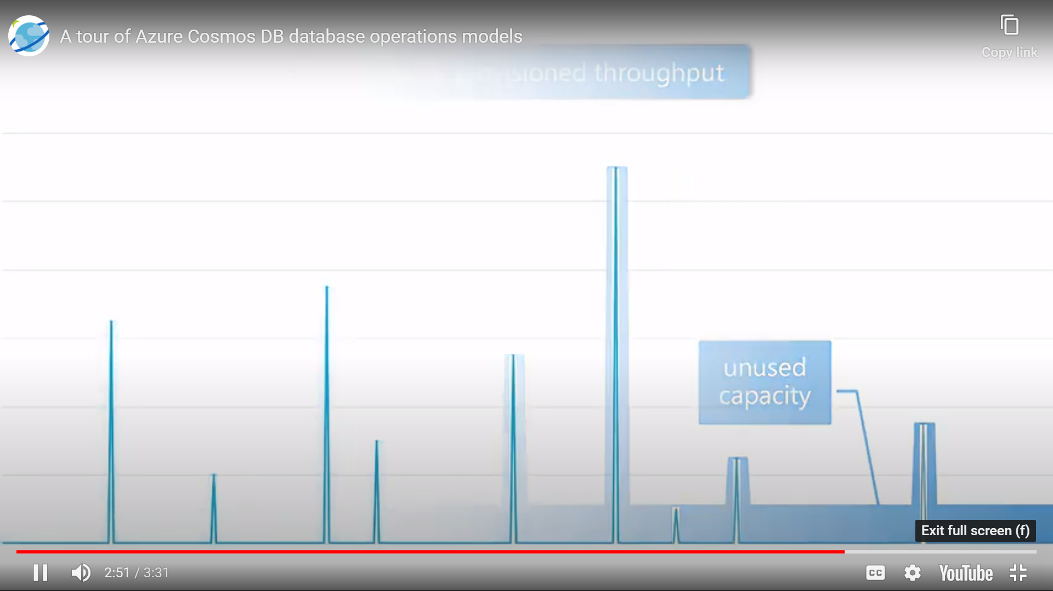 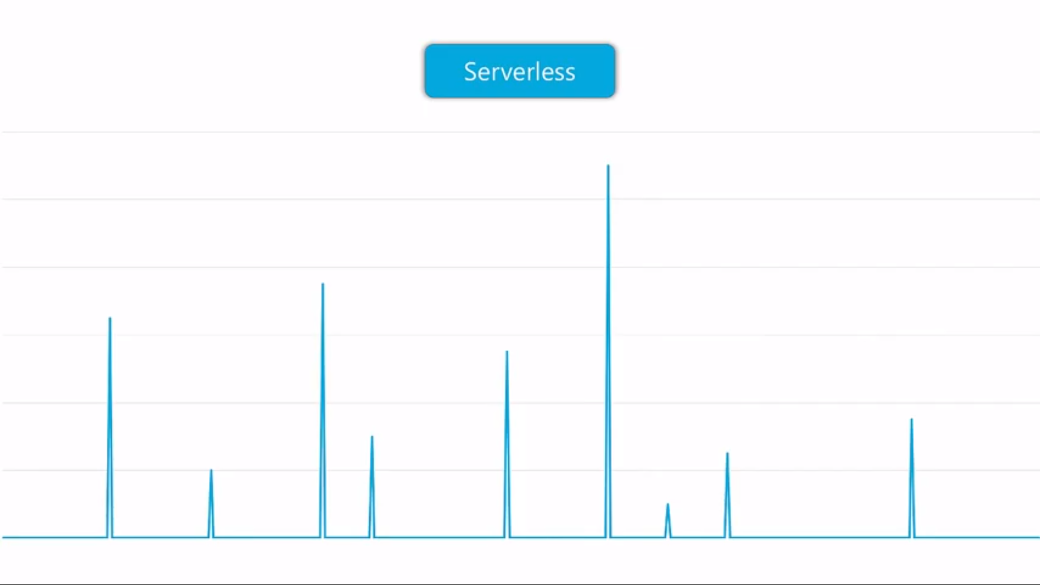

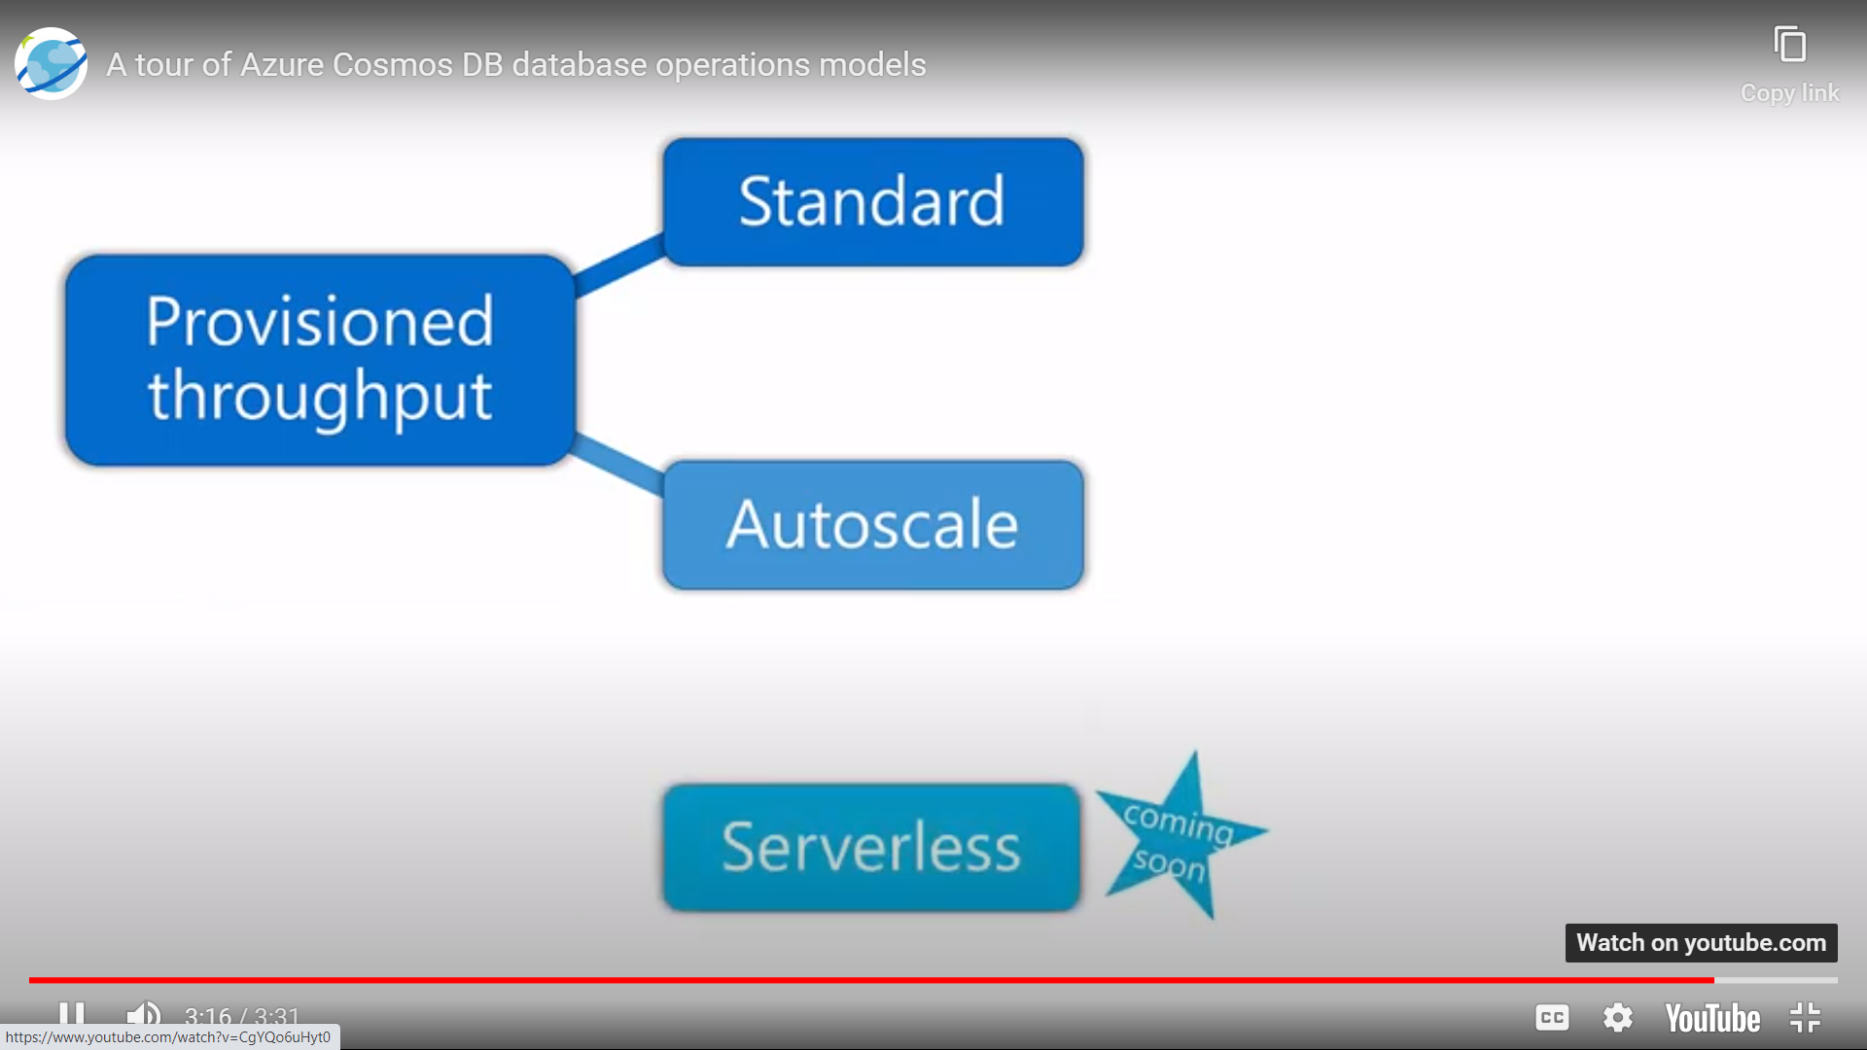

<https://docs.microsoft.com/en-us/azure/cosmos-db/throughput-serverless>

